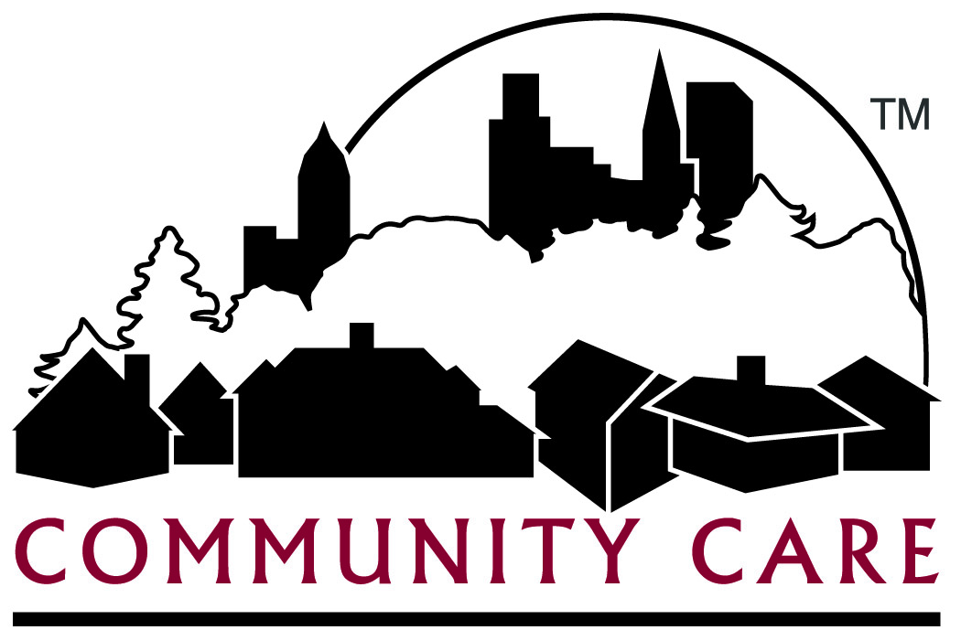
Community Care, Inc. (CCI) - Provider Advisory Committee
AGENDA

Date: Wed., September 19, 2018 Time: 10:00 am – 12:00 noon Location: Community Care Inc., Waukesha Site - Large Conference Room

Recorder: Faith Wenrich

Attendance: Drury Ferris Gudwer Jones Juett Krzanowski
Lavrenz McCook Moen Nardi Reale Tasch
Wenrich Ramage (Guest)

Topic | Discussion
Introductions | Dan Drury - Options for Community Growth  April Juett - AJ's Living  Bill Gudwer - Limitless Possibilities  Victor Reale - Atrium  Mike Nardi - Southport Transport  CCI Staff – Matt Moen, Patti Ferris, Jill Krzanowski, Faith Wenrich, Terry Ramage
Direct Care Workforce Funding (DCW) | Moen- CCI sent DCW funding checks in the middle of August based on the service types eligible, CCI’s claims data and if the DCW agreements were signed and returned. Each check was designated as related to FC or Partnership program services and payable to the contracted Legal Entity. 16 of our providers did not return the agreement and 15 replied they did not want the check(s). Providers receiving the funds were required to complete a survey and attestation on the DHS website with no longer than 30 days to cash the checks in order to be eligible for 2nd quarter funding. If the conditions set forth by DHS for the funding are not met, CCI will need to recoup the funds from the non-compliant providers.  Drury – Was it suggested that the survey should ask for the tax ID of providers?  Moen – Yes  Drury – Will there be an audit?  Moen – Probably  Reale – We (Atrium) received a check from Inclusa with instructions to add it to our revenue account, is this correct?  Moen – We (CCI) are not involved in how other MCOs conducted the distribution of their funds. CCI followed the State’s instruction and advised that only direct care workers must receive the funds.
Provider Survey –  Handout | Ferris – CCI should be surveying providers to collect and review provider feedback. We have requirements for feedback on specific topics, see the Fall 2018 Provider Survey Sample Questions handout. Emails will be sent to providers with a link to complete the survey. Do any of you have some input regarding this draft?  Drury – How do we get the relevant department to answer the questions?  Moen – The survey link can be shared with provider staff to complete.  Reale – Do MCOs ever meet as a whole?  Moen – No, we are competitors and while the state is very specific about rules and outcomes we may each get those results differently  Moen- When calling our Provider Hotline, do you know who to contact in provider management?  Juett – I have never had a problem, you are good with re-direction  Moen – What if we ask about when you call the provider hotline, are the prompts helpful?  Gudwer – I called a few times to correct claims issues and couldn’t get them taken care of so we wrote them off  Moen – We now have 4 account representatives that conduct claims analysis and one is assigned to each provider. If you have issues and cannot resolve them, contact your account rep.  Drury – Is there a way to be notified of team changes  Ramage – Some teams send letters and at a minimum a notification phone call  Drury – More than not there is a gap during the changeover of care managers or RNs assigned. Could we add the supervisor in this instance?  Ramage – If you’re not getting a response contact the staff supervisor  Moen – you can also contact your account rep to assist
Long Term Care Network Adequacy | Moen – At our last meeting we asked if you (the committee) had any suggestions for measuring CCI’s Long Term Care Provider Network Adequacy. We have run historical data of need per time frame. Some categories are not easy to track.  Gudwer – For every specific code?  Moen - Member enrollment per county vs provider type per county – do we have enough?
MetaStar | Moen – We have our MetaStar quality improvement review in October 2018
Medicare Services | Moen –Family Care services for members with Medicare primary, we cannot limit which providers they use. When members use Out of Network providers, it is our goal to make it easier for payment of the Medicaid portion. No authorizations are the goal but there will still be an EOB (Explanation of Benefits) Some of the services most affected include DME, Mental Health, and Therapies.
Provider Database/Directory Updates | Moen – The CCI website has a searchable online provider directory and the State of Wisconsin audits for 12 elements while CMS audits if these elements are correct. On 10/22/18, CCI is launching an updated version of this directory adding provider’s hours of operation, website address, any specialties and whether or not the agency has completed cultural competency training. The account reps will be gathering information from you. Staffing ratio will be recorded. The provider database is not used for contact for teams to place members.
Provider Application Training Sessions | Moen – CCI now holds morning and afternoon provider application training sessions on the 2nd Monday of each month. If providers have been denied and wish to re-apply they must first attend one of these training sessions. After attending they can re-submit within 30 days whether it’s the second or third time. There will be no more than 3 denials and a 5 day cure period for any contract application requirement. At the meetings we explain that the correct answer to any question is an honest answer. If they had to be licensed or certified by the state, depending on the provider service type, CCI may have additional requirements and standards as an organization for our network. Our application process is similar to a job application; we both have the right to decide if it’s a “good fit” and there are no guarantees of a contract. We, provider management, are willing to attend any meetings that you may have in your agency.
Guest – Terry Ramage – CCI Family Care Supervisor | Ramage – I have been with CCI 9 years come November. My role is Family Care Supervisor within the Family Care Kenosha Administration. I expect timely communication from care teams. The teams should return contact within 1 business day and auths should be entered before the service start date. If you can’t reach a care team, you can ask for a supervisor to assist  Nardi – Auths can take a long time to get and I now insist on an auth first  Moen- If you have issues getting an auth you can also contact your account rep for assistance
Future Agenda Topics | Moen - Contract changes  Drury – Day programs, workshops are changing because of Federal Regulations  Moen – We can invite Jennifer Flemal, CCI’s Regional Program Director, to our meeting as she is our employment specialist  Pay for Performance member surveys – DHS withheld funds from the MCOs to re-issue based on the survey outcomes  Our next meeting will be in December or early January, CCI will be in contact with Committee members

