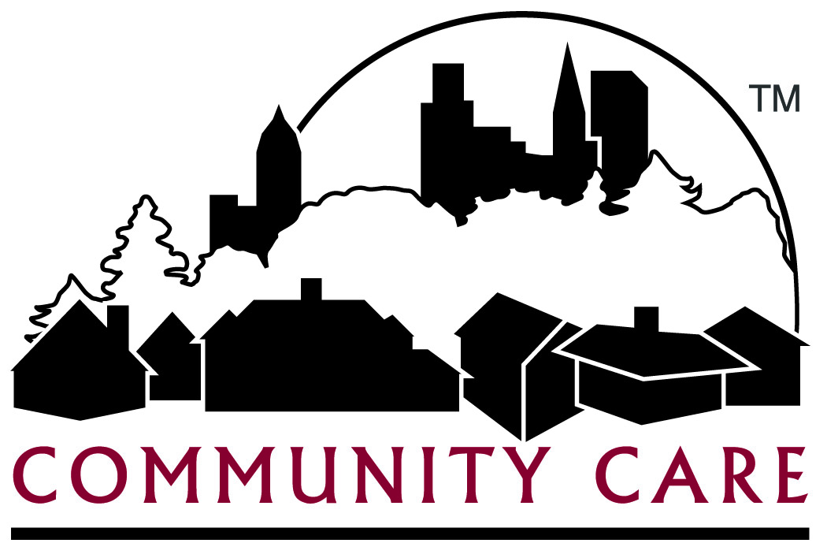
Community Care, Inc. (CCI) - Provider Advisory Committee
AGENDA

Date: Wed., July 31, 2019 Time: 10:00 am – 12:00 noon Location: Community Care Inc., Waukesha Site - Large Conference Room

Recorder: Faith Wenrich

Attendance: Drury Ferris Gudwer Jones Juett Krzanowski
McCook Moen Nardi Reale Wenrich
(Guest) Rachel Haggarty (Guest) Kelly Her

Introductions | - Introductions – Guest Rachel Haggarty, CCI - Quality Management Coordinator  Guest Kelly Her , CCI - Financial Eligibility Supervisor
Haggarty – | 2019 Quality Work Plan – A few of the 2019 Quality Plan goals for all 3 programs include:  - Reach a composite score of over 90% compliant for files reviewed  - Examine the adequacy & timeliness of Long Term Care Functional Screens  - Improve reporting by both the care teams and providers of member incidents in a timely manner.  - Increase Influenza and Pneumonia vaccination rates for both members and staff. These vaccinations are “strongly recommended” but not mandatory  - Reduce use of antipsychotic medication by increasing dementia screenings and re-examination of members 65 and older currently using those medications  To summarize, the Quality Department’s plan is focused on Preventative Care and Wellness, Improvement of Advanced Care planning, monitoring member satisfaction, incidents, grievances and appeals as well as continuing Member Advisory Committee meetings and member surveys. Website link for Summary of 2019 Quality Plan: http://www.communitycareinc.org/docs/default-source/quality/2019-quality-work-plan.pdf?sfvrsn=817eb9f6_2  - Wisconsin Immunization Registry (WIR) information:  http://www.communitycareinc.org/docs/default-source/provider-education/wir-provider-benefits.pdf?sfvrsn=6691b9f6_2
Her | - Some enrolled members have a cost share responsibility which is similar to a health insurance premium. This cost share amount can be no more than $2777 and is based on the member’s income and allowable expenses. The local county ADRCs determine the cost share amount and reports it to us for collection. CCI sends a bill to the member stating payment is due by the 15th of every month as a condition of eligibility. CCI makes all attempts to collect the money due but if not paid, we must notify the ADRC and then the ADRC ends the member’s enrollment.  Reale – If enrollment is mid-month and the state receives the cost share amount, will a SNF be reimbursed and who collects the payment?  Drury – What is considered an allowable expense?  Her –Shelter, Utilities, Child Support, Med Remedial
Moen | - WALA Press Release dated Wednesday, July 3, 2019 regarding Governor Evers budget https://cdn.ymaws.com/ewala.org/resource/resmgr/news/wala_press_release_07-03-201.pdf  We haven’t seen any changes due to Governor Evers budget mentioned in the WALA press release and will wait for any instructions. Personal Care Agency rates were increased last year (2018). https://www.forwardhealth.wi.gov/kw/pdf/2018-01.pdf  - GSR 9 & 10 – (Geographic Service Regions)  GSR 9 includes Fond du Lac and Winnebago and GSR 10 is Outagamie and Winnebago. Both 9&10 are currently covered by Community Care Inc and Lakeland Care. RFPs were collected from and CCI notified that we are not one of the 2 MCOs assigned to these regions. CCI has filed a protest for review, which may be followed by an appeal and review and during this process, however long it takes, CCI will continue to serve these counties.  - Finance update  - 2020 Assumptions – 2019 will result in a gain for CCI due to state relief.  - Residential Rebalancing – CCI has formed internal workgroups and plans to reduce our frail elder and physically disabled member placements in AFH facilities with alternatives to reduce our costs per member in Milwaukee, Racine and Kenosha counties. As of May 7, 2019 CCI will not add any AFHs or Certified Corporate homes to our network in those 3 counties with no exceptions. Instead, we are contacting contracted CBRFs and RCACs in our network for vacancies as well as reaching out to non-contracted, Licensed CBRFs and Certified RCACs to invite them to our network. This work will ultimately be conducted in all our Counties.  - EVV Update - Informational sessions with members and providers have been held to discuss the Electronic Visit Verification process and to take questions or note concerns. DHS has requested an extension for the hard launch until 2021 to address any exceptions or nuances as it relates to each provider and MCO’s authorizations, billing systems and member homes.  - P4P and CIE Update –P4P (pay for performance) is based on CIE (Competitive Integrated Employment) for 2019. Care teams are categorizing members into 5 target groups related to CIE:  - Currently working in CIE  - Interested in working in CIE/ Knows their desired career  - Interested in working in CIE/ Unsure of their desired career  - May be interested in CIE  - Not interested in CIE  - Provider Fair/Forum – Some providers have mentioned that other organizations have hosted a provider fair or forum where they have shared their products such as PERS systems, etc. Is this something that you may be interested in?  Jones: if we look at it as provider to provider otherwise I don’t see what the agenda would be  Reale: We were invited to such an event and didn’t go  Gudwer: I didn’t go either
Krzanowski | - Credentialing and CredSimple (NCQA-certified CVO) - In the past CCI was credentialing all Healthcare providers by contacting the group or individuals then entering the information gathered into our systems. Using this method, an internal audit found that we were not in compliance. To correct this, CCI is now working with the credentialing software group, CredSimple. A CCI credentialing specialist gathers specific information from all HC provider groups and individuals sending it to CredSimple for review. After reviewing the data using multiple resources, CredSimple then alerts us of any issues discovered. A CCI review committee then examines the information and either approves or chooses not to approve a provider into our network using Best Practice guidelines therefore improving our standards and contract efficiency.
Future Meeting Date | Next meeting date: Wednesday, November 13, 2019

